FOR IMMEDIATE RELEASE
February 10, 2026

CONTACT: Erin Zeigler
CELL: 629-277-2458

TRAFFIC ADVISORY

Nighttime Closures and Detour Scheduled for I-65 Bridge Construction

Nashville, Tenn. - The Tennessee Department of Transportation (TDOT) will conduct nighttime closures of US-31W (State Route 41) and Interstate 65 in Sumner County.
For two nights starting Thursday, February 12, through Friday, February 13, crews with Jones Bros. will detour northbound Interstate 65 and close US-31W in both directions to prepare for a deck pour on the new I-65 bridge over US-31W. The closures will take place from 8 p.m. – 5 a.m.
A detour will be in place to divert motorists off the interstate at the US-31W Exit 98 ramp and back on using the I-65 entrance ramp.

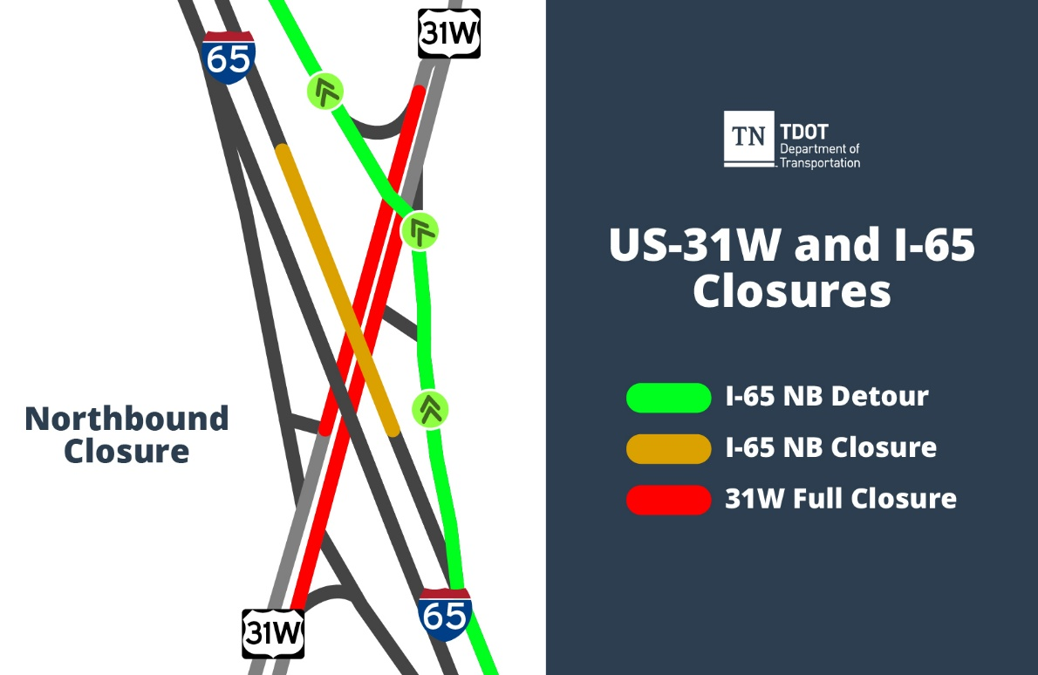
I-65 Northbound Detour
This work is part of TDOT’s I-65 Phase 3 Widening & Improvements project, which began construction in March 2025. In addition to adding a travel lane in each direction, this work includes the replacement of bridges over US-31W, Long Hollow Pike, East Cedar Street, and Mansker Creek, as well as other improvements.
All work is weather-dependent. As always, drivers are reminded to allow additional time, slow down, and move over when traveling through a work zone. The Move Over Law was passed in 2006. The penalty for violating the law in Tennessee includes the possibility of up to 30 days in jail and a maximum fine of $500.
Motorists can report potholes to TDOT by calling the TDOTFIX Hotline at 833-TDOTFIX or using this online form: TDOT Maintenance Request. The TDOT SmartWay Map (https://smartway.tn.gov) provides the latest traffic updates on construction activity. Travelers can also call 511 for travel information.

*US-31W is a north/south highway.

###

