FOR IMMEDIATE RELEASE
November 19, 2025

CONTACT: Erin Zeigler
CELL: 629-277-2458

TRAFFIC ADVISORY

Nighttime Closures Updated for I-65 Bridge Construction

Nashville, Tenn. - The Tennessee Department of Transportation (TDOT) has an updated schedule for nighttime closures of US-31W (State Route 41) and Interstate 65 in Sumner County.
Since Sunday, November 16, crews with Jones Bros. have been conducting lane closures on I-65 and US-31W in both directions to set steel beams for the new I-65 bridge over US-31W. The closures are taking place from 8 p.m. to 5 a.m. for approximately 12 nights, with an expected completion date of December 4. The following closure schedule is subject to change as work progresses and adjustments are needed:
Date (8 p.m. – 5 a.m.) | I-65 Impacted Lane | US-31W Impacted Direction*
Sunday, Nov. 16 | I-65 SB inside lane closure | Northbound closed
Monday, Nov. 17 | I-65 NB inside lane closure | Northbound closed
Tuesday, Nov. 18 | I-65 NB inside lane closure | Northbound closed
Wednesday, Nov. 19 | I-65 SB inside lane closure | Both directions closed
Thursday, Nov. 20 | I-65 SB inside lane closure | Both directions closed
Sunday, Nov. 23 | I-65 SB & NB inside lane closures | Both directions closed
Monday, Nov. 24 | I-65 SB & NB inside lane closures | Both directions closed
Tuesday, Nov. 25 | I-65 SB & NB inside lane closures | Both directions closed
Monday, Dec. 1 | I-65 NB closed over US-31W | Both directions closed
Tuesday, Dec. 2 | I-65 NB closed over US-31W | Both directions closed
Wednesday, Dec. 3 | I-65 NB closed over US-31W | Both directions closed
This closure table will be updated on the project website.
Detour signage will be in place. When I-65 over US-31W is closed, motorists will be diverted off the interstate at the US-31W exit ramp and back on using the I-65 entrance ramp. That detour and the recommended detours for US-31W are as follows:
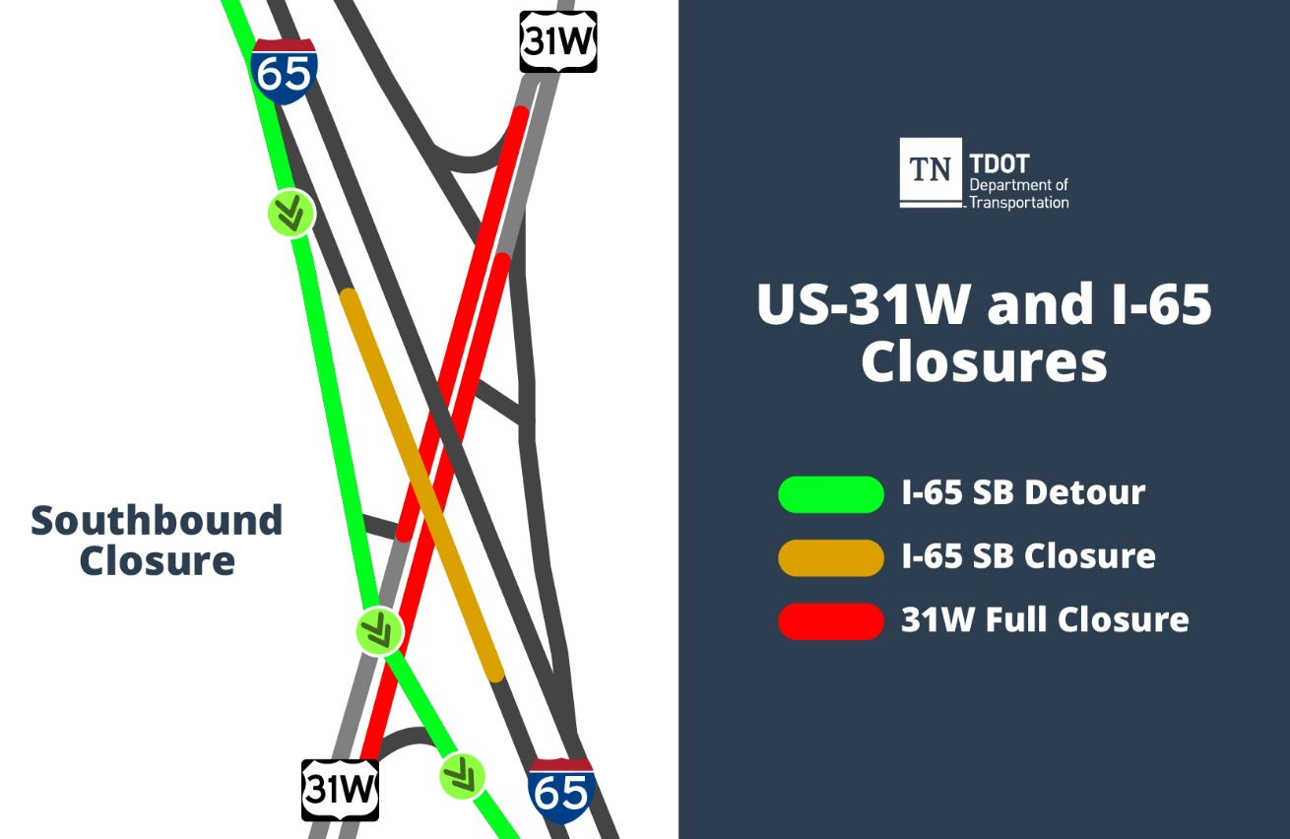

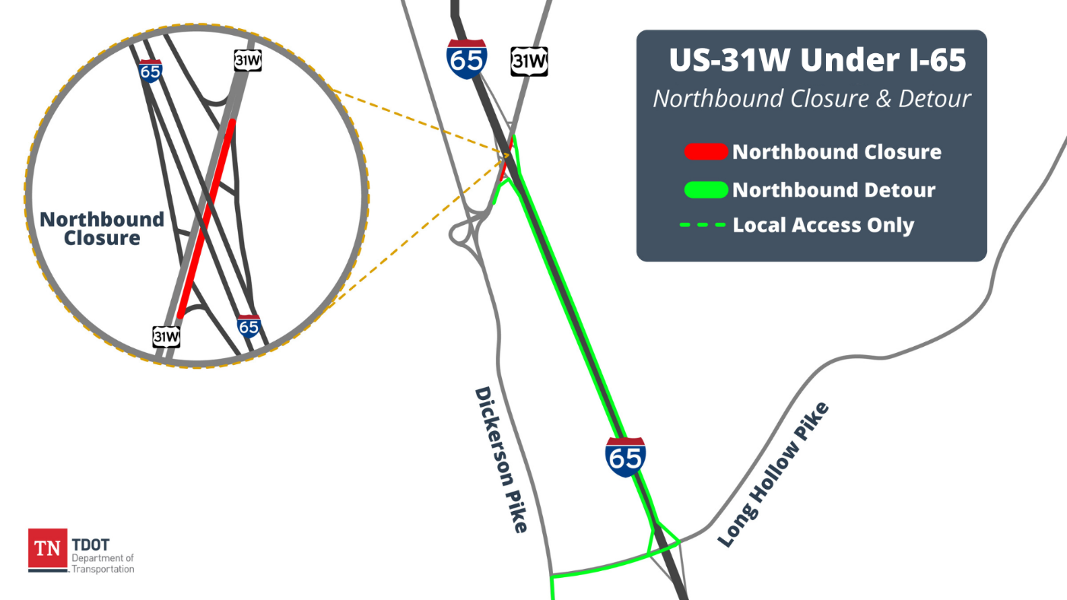

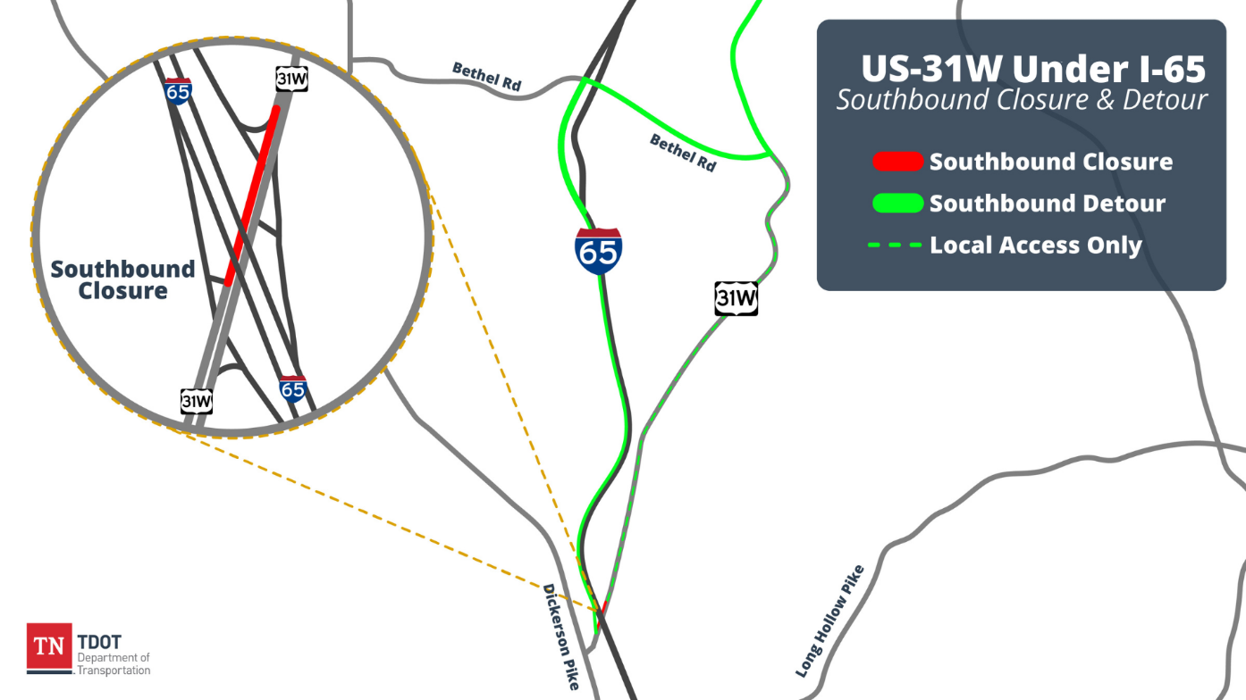
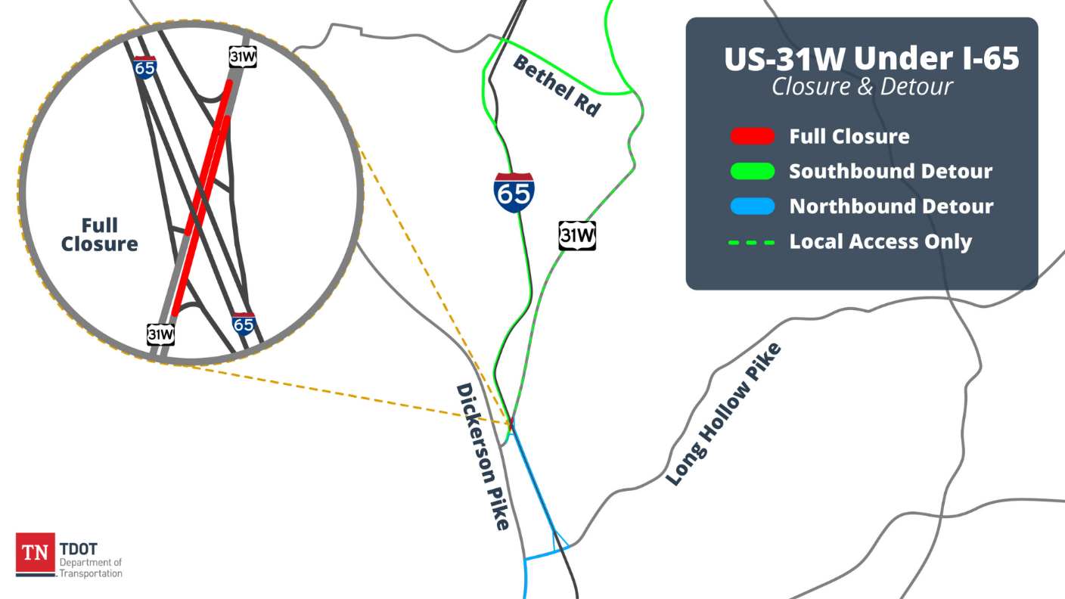
This work is part of TDOT’s I-65 Phase 3 Widening & Improvements project, which began construction in March 2025. In addition to adding a travel lane in each direction, this work includes the replacement of bridges over US-31W, Long Hollow Pike, East Cedar Street, and Mansker Creek, as well as other improvements.
All work is weather-dependent. As always, drivers are reminded to allow additional time, slow down, and move over when traveling through a work zone. The Move Over Law was passed in 2006. The penalty for violating the law in Tennessee includes the possibility of up to 30 days in jail and a maximum fine of $500.
Motorists can report potholes to TDOT by calling the TDOTFIX Hotline at 833-TDOTFIX or using this online form: TDOT Maintenance Request. The TDOT SmartWay Map (https://smartway.tn.gov) provides the latest traffic updates on construction activity. Travelers can also call 511 for travel information.

*US-31W is a north/south highway.

###

